Geometric Figure Rearrangement

Definition
# Source: AI Source: Provided by: [Data Path: Persons Table -> ID Column: 1, Name_En Column: Motasem Essam] -> From: [ChatGPT] on [7/25/2026]
Geometric Figure Rearrangement is the process of changing the positions, orientations, or order of geometric figures or their parts to create a new arrangement, simplify a geometric problem, or reveal geometric relationships while preserving specified properties.
Rearrangement may involve moving, rotating, reflecting, or repositioning pieces without necessarily changing their shapes or sizes.

Simple Definition
# Source: AI Source: Provided by: [Data Path: Persons Table -> ID Column: 1, Name_En Column: Motasem Essam] -> From: [ChatGPT] on [7/25/2026]
Geometric figure rearrangement means moving or reorganizing geometric shapes or their parts to form a different arrangement or make a geometric problem easier to solve.
Example: Dividing an L-shaped figure into two rectangles, then rearranging those rectangles to form a larger rectangle.

Main Classification
# Source: AI Source: Provided by: [Data Path: Persons Table -> ID Column: 1, Name_En Column: Motasem Essam] -> From: [ChatGPT] on [7/25/2026]
The following is a practical classification of geometric figure rearrangement methods. These categories are descriptive rather than a universally standardized mathematical taxonomy, and some may overlap.

1. Positional Rearrangement
# Source: AI Source: Provided by: [Data Path: Persons Table -> ID Column: 1, Name_En Column: Motasem Essam] -> From: [ChatGPT] on [7/25/2026]
Changing the positions of figures or pieces without changing their orientations.
Example: Moving one rectangle beside another to form a larger rectangle.
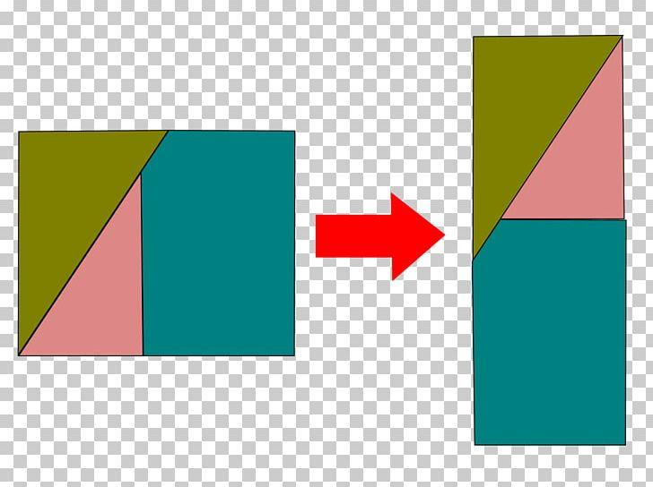
Detailed Explanation and Examples
Definition: Moving geometric figures from one position to another without necessarily rotating or reflecting them.
Example: Two rectangles each measuring $4×2$units are placed side by side along their 2-unit sides.
- First rectangle area: $4×2=8$.
- Second rectangle area: $4×2=8$.
- Combined area: $8+8=16$square units.
If placed appropriately, the result is a rectangle measuring $4×4$units.

2. Rotational Rearrangement
# Source: AI Source: Provided by: [Data Path: Persons Table -> ID Column: 1, Name_En Column: Motasem Essam] -> From: [ChatGPT] on [7/25/2026]
Rotating a figure or one of its parts to fit a new position.
Example: Rotating a triangular piece by 90∘90^\circ90∘ to fit into a rectangular arrangement.
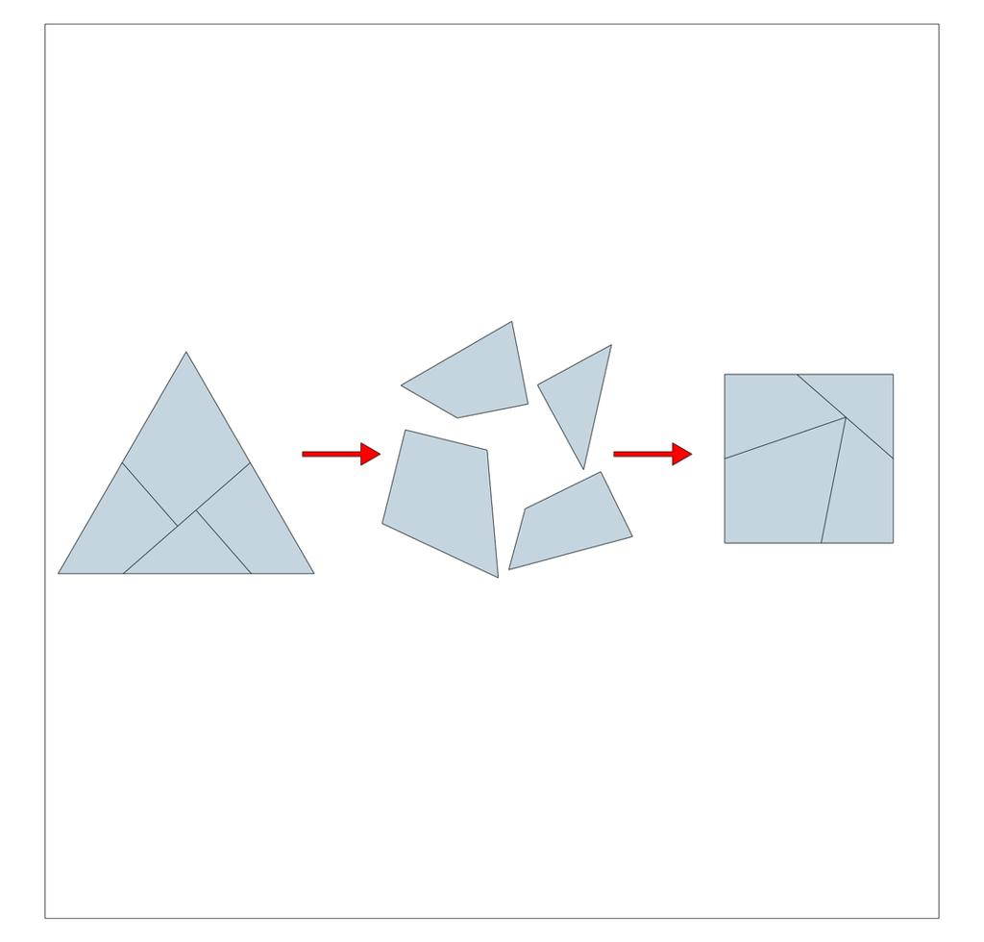
Detailed Explanation and Examples
Definition: Changing the orientation of a geometric figure by rotating it around a fixed point or center.
A rotation preserves lengths, angles, area, and shape.
Example: A rectangle measuring $6×2$units is rotated through ${90}^{∘}$. Its dimensions become $2×6$, but its area remains
$$A=6×2=12$$
square units.

3. Reflective Rearrangement
# Source: AI Source: Provided by: [Data Path: Persons Table -> ID Column: 1, Name_En Column: Motasem Essam] -> From: [ChatGPT] on [7/25/2026]
Reflecting one or more pieces to create a new arrangement.
Example: Reflecting a triangular piece so its sloping edge matches another piece.

Detailed Explanation and Examples
Definition: Repositioning a figure by reflecting it across a line or plane.
Reflection preserves lengths and angles but reverses orientation.
Example: Reflecting a right triangle across one of its legs can produce a congruent triangle on the opposite side of that leg. Together, the two triangles may form a rectangle or another quadrilateral, depending on their arrangement.

4. Piece-Reordering Rearrangement
# Source: AI Source: Provided by: [Data Path: Persons Table -> ID Column: 1, Name_En Column: Motasem Essam] -> From: [ChatGPT] on [7/25/2026]
Changing the order of pieces while keeping each piece's shape and size.
Example: Rearranging triangular pieces of a square to create a parallelogram.
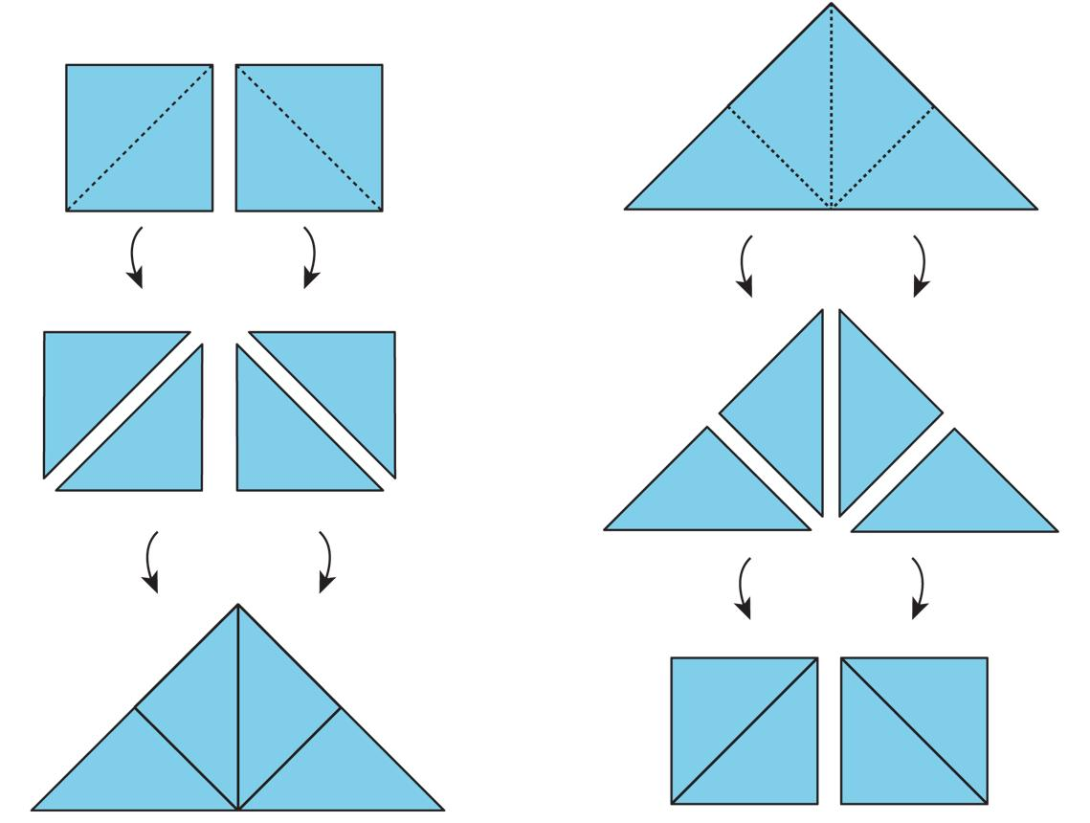
Detailed Explanation and Examples
Definition: Changing the order or placement of individual components of a divided figure.
Example: A square is divided into four congruent triangles. The triangles are rearranged into another shape.
If all four triangles are used exactly once without gaps or overlaps, the total area remains equal to the area of the original square.

5. Shape-Forming Rearrangement
# Source: AI Source: Provided by: [Data Path: Persons Table -> ID Column: 1, Name_En Column: Motasem Essam] -> From: [ChatGPT] on [7/25/2026]
Reorganizing pieces to create a target shape, such as a rectangle, square, or triangle.
Example: Rearranging pieces of an L-shaped region to form a rectangle.
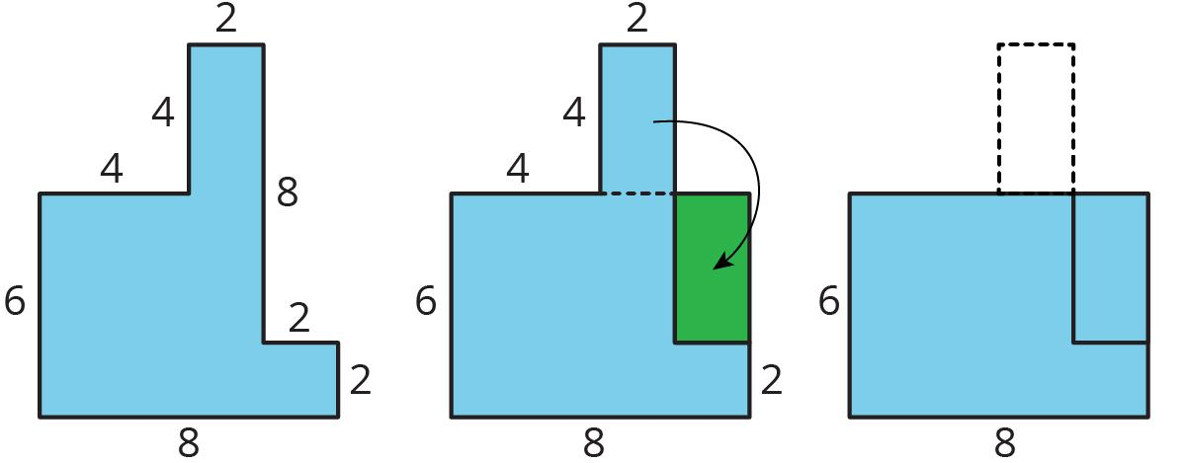
Detailed Explanation and Examples
Definition: Repositioning geometric pieces to construct a particular target figure.
Example: An L-shaped region can be divided into two rectangles. One rectangle is then moved to fill the missing corner, producing a larger rectangle if the dimensions and pieces permit it.
This method is useful in geometry puzzles and area calculations.

6. Puzzle-Based Rearrangement
# Source: AI Source: Provided by: [Data Path: Persons Table -> ID Column: 1, Name_En Column: Motasem Essam] -> From: [ChatGPT] on [7/25/2026]
Moving a collection of geometric pieces under specified rules to achieve a target configuration.
Example: Rearranging tangram pieces to form a square or another polygon.
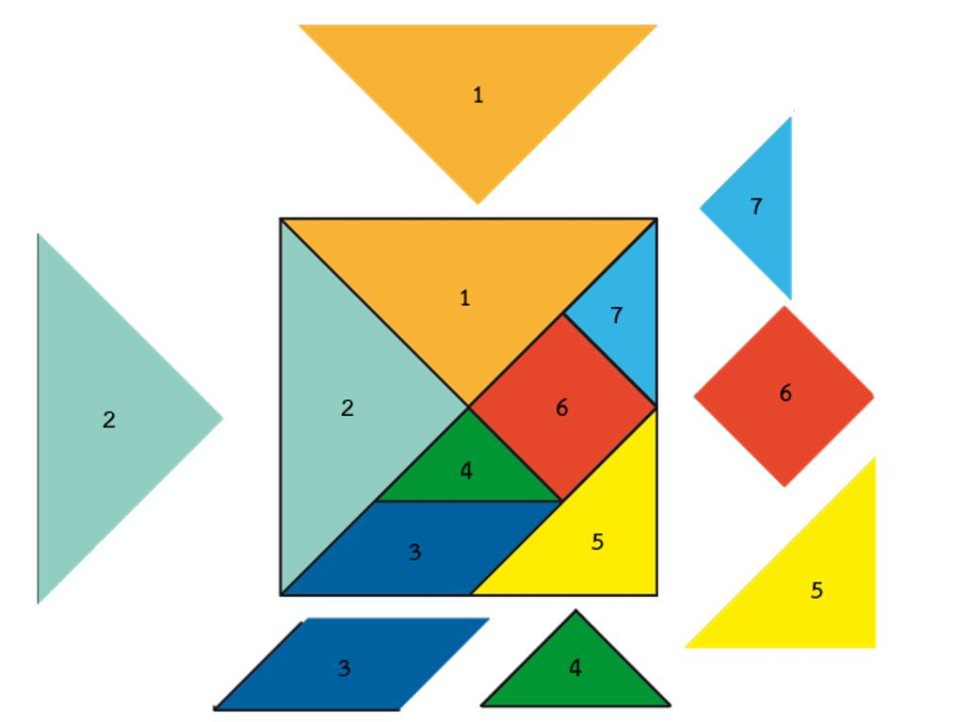
Detailed Explanation and Examples
Definition: Rearranging geometric pieces according to constraints, such as using every piece exactly once or forming a prescribed polygon.
Example: A tangram contains seven standard pieces. By rotating, reflecting, and repositioning them, one can form a square, a triangle, or various other silhouettes.
The target shape must be achievable using the available pieces and the puzzle's rules.

7. Area-Preserving Rearrangement
# Source: AI Source: Provided by: [Data Path: Persons Table -> ID Column: 1, Name_En Column: Motasem Essam] -> From: [ChatGPT] on [7/25/2026]
Rearranging pieces to demonstrate that two figures have equal areas.
Example: Rearranging the pieces of a polygon into a rectangle without gaps or overlaps.
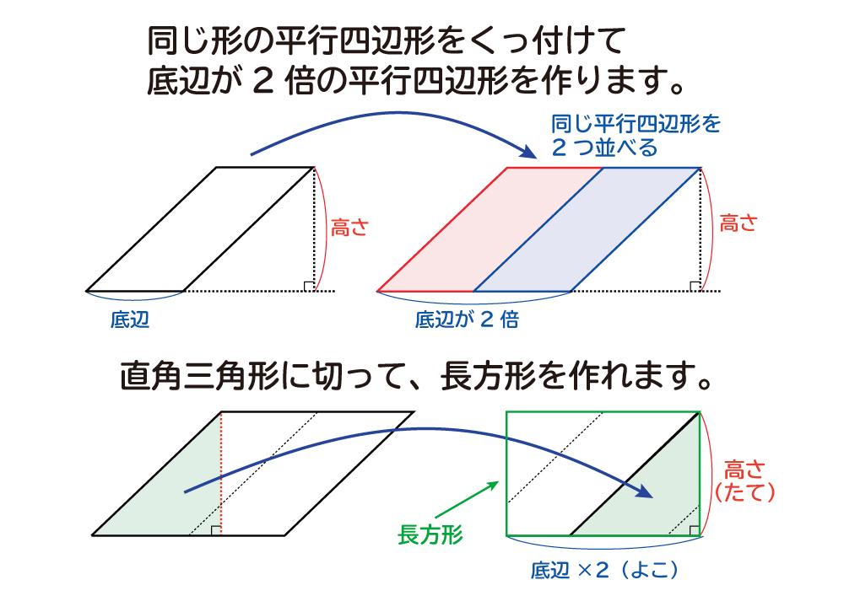
Detailed Explanation and Examples
Definition: Rearranging pieces to show that the original and resulting figures have the same area.
If a figure is divided into non-overlapping pieces with areas $A_{1},A_{2},…,A_{n}$, then
$$A_{\text{original}}=\sum_{i=1}^{n}{A_{i}}$$
If the same pieces are rearranged without gaps or overlaps,
$$A_{\text{original}}=A_{\text{rearranged}}$$
Example: A $10×4$rectangle has area
$$A=10×4=40$$
square units. Dividing it into smaller pieces and rearranging those pieces cannot change their total area, provided no material is removed or added.

8. Problem-Simplifying Rearrangement
# Source: AI Source: Provided by: [Data Path: Persons Table -> ID Column: 1, Name_En Column: Motasem Essam] -> From: [ChatGPT] on [7/25/2026]
Changing the arrangement to expose a useful property or make a calculation easier.
Example: Rearranging components of a composite figure so its area can be calculated using familiar formulas.
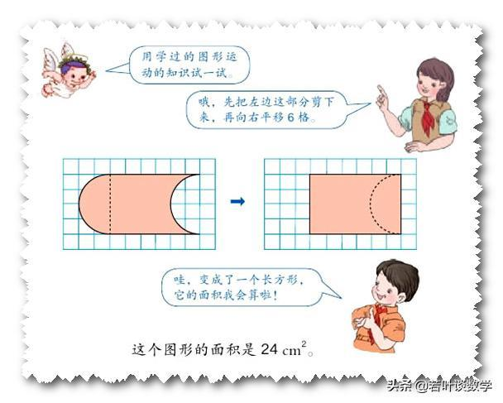
Detailed Explanation and Examples
Definition: Changing a figure's arrangement to make its geometric properties easier to identify or calculate.
Example: A composite region consists of a rectangle and a semicircle attached along one side. Rather than treating the entire outline as one unfamiliar shape, calculate the areas separately:
$$A_{\text{total}}=A_{\text{rectangle}}+A_{\text{semicircle}}$$
For a rectangle of length $L$and width $2r$, with a semicircle of radius $r$,
$$A_{\text{total}}=2rL+\frac{πr^{2}}{2}$$
This is a decomposition-based calculation; physically rearranging the pieces is not necessary.

Mathematical Principles
# Source: AI Source: Provided by: [Data Path: Persons Table -> ID Column: 1, Name_En Column: Motasem Essam] -> From: [ChatGPT] on [7/25/2026]
Geometric figure rearrangement commonly uses these principles:
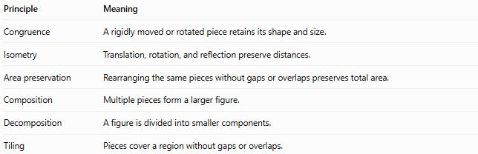
Principle | Meaning
Congruence | A rigidly moved or rotated piece retains its shape and size.
Isometry | Translation, rotation, and reflection preserve distances.
Area preservation | Rearranging the same pieces without gaps or overlaps preserves total area.
Composition | Multiple pieces form a larger figure.
Decomposition | A figure is divided into smaller components.
Tiling | Pieces cover a region without gaps or overlaps.
Important distinction: Not every rearrangement preserves every property. Translation, rotation, and reflection preserve lengths and angles. Stretching or non-uniform scaling can change them. Area is preserved only when the operation or piece arrangement preserves the total area.

5. Rearrangement vs. Related Concepts
# Source: AI Source: Provided by: [Data Path: Persons Table -> ID Column: 1, Name_En Column: Motasem Essam] -> From: [ChatGPT] on [7/25/2026]
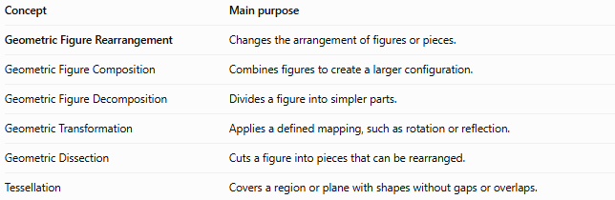
Concept | Main purpose
Geometric Figure Rearrangement | Changes the arrangement of figures or pieces.
Geometric Figure Composition | Combines figures to create a larger configuration.
Geometric Figure Decomposition | Divides a figure into simpler parts.
Geometric Transformation | Applies a defined mapping, such as rotation or reflection.
Geometric Dissection | Cuts a figure into pieces that can be rearranged.
Tessellation | Covers a region or plane with shapes without gaps or overlaps.
These concepts can overlap. For example, a dissection puzzle may involve decomposition, transformations, rearrangement, and composition.

6. Classification Summary
# Source: AI Source: Provided by: [Data Path: Persons Table -> ID Column: 1, Name_En Column: Motasem Essam] -> From: [ChatGPT] on [7/25/2026]
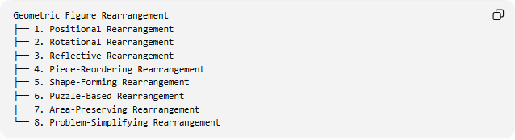
Geometric Figure Rearrangement
├── 1. Positional Rearrangement
├── 2. Rotational Rearrangement
├── 3. Reflective Rearrangement
├── 4. Piece-Reordering Rearrangement
├── 5. Shape-Forming Rearrangement
├── 6. Puzzle-Based Rearrangement
├── 7. Area-Preserving Rearrangement
└── 8. Problem-Simplifying Rearrangement

7. Key Points
# Source: AI Source: Provided by: [Data Path: Persons Table -> ID Column: 1, Name_En Column: Motasem Essam] -> From: [ChatGPT] on [7/25/2026]
- Rearrangement changes the positions or orientations of figures or their parts.
- Pieces can be translated, rotated, reflected, or reordered.
- Rearranging pieces can reveal equal-area relationships and simplify geometric calculations.
- Area remains unchanged when exactly the same pieces are used without gaps, overlaps, cutting losses, or added material.
- The listed categories are a practical organizational scheme, not a universal formal classification.

8. Conclusion
# Source: AI Source: Provided by: [Data Path: Persons Table -> ID Column: 1, Name_En Column: Motasem Essam] -> From: [ChatGPT] on [7/25/2026]
Geometric Figure Rearrangement is a method for reorganizing geometric figures or their components to form new configurations, solve puzzles, demonstrate area relationships, or simplify problems. It is closely related to geometric transformations, composition, decomposition, and dissection.

